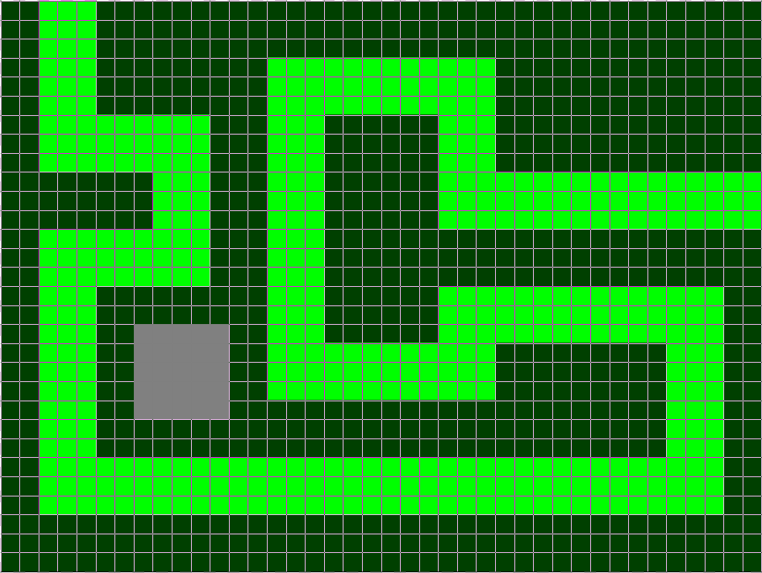Level 1

Tutorial/Novice difficulty

1 entrance

1 exit

1 obstruction

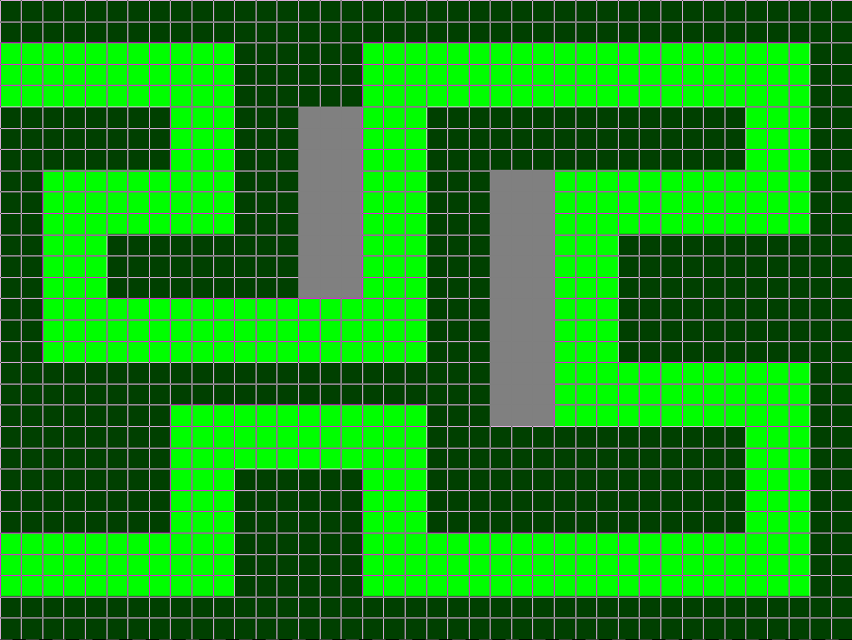

Level 2

Novice difficulty

1 entrance

1 exit

2 obstructions

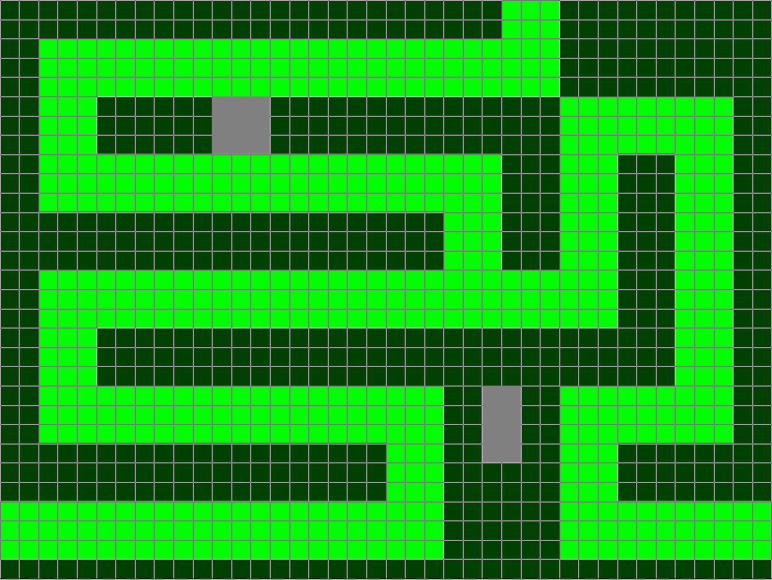Level 3

Moderate difficulty

1(2) entrance

1 fork in the road

2 obstructions

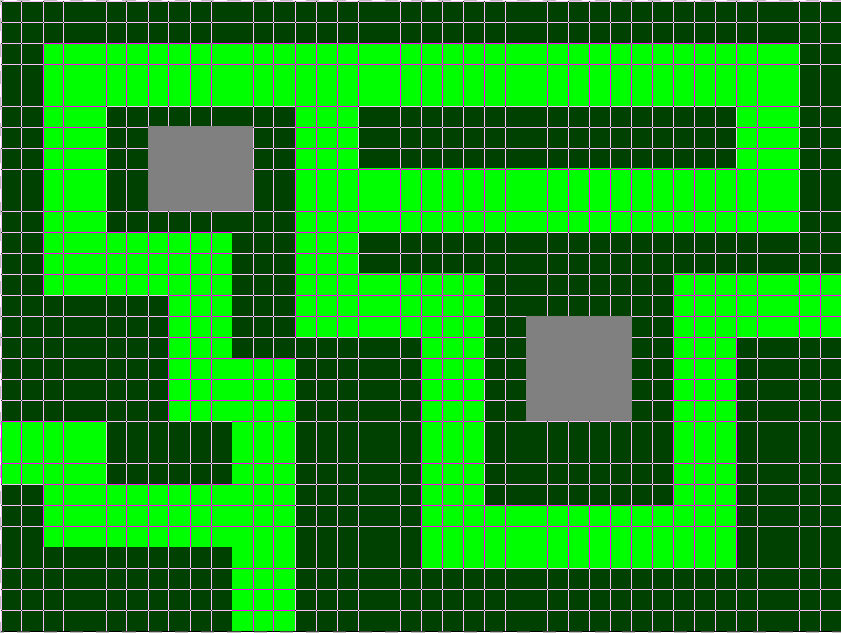2(1) exit(s)

Level 4

2 Entrances(1)

2 forks in the road

2 obstructions

1(2) exit(s)